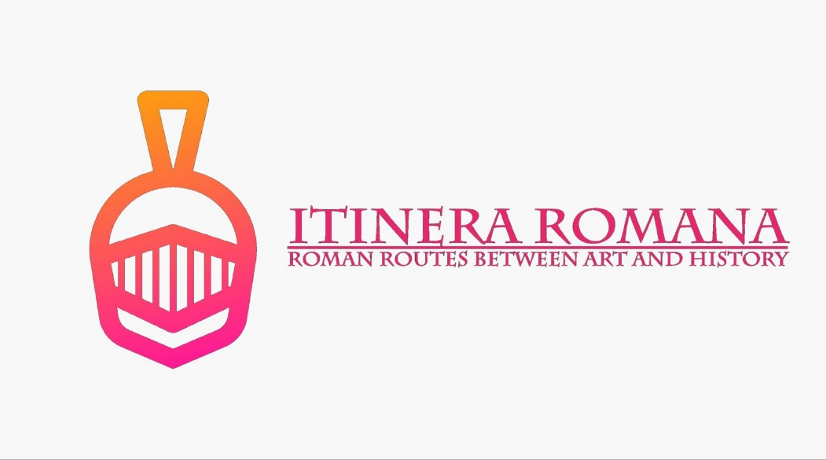

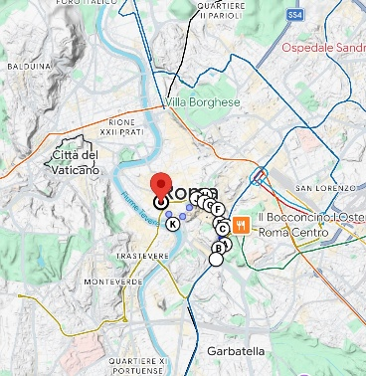

2° Percorso – “Iter Giulio Cesare”

Where: Rione X Campitelli


How: Walking

Time: 1:30 Hour

Total Trip Time: From 6 up to 8 Hours

Departure: Circo Massimo (Metro B)

Arrival: Isola Tiberina or Largo Argentina

VS. 2 | English Version | Tickets | Booking Yes
VS. 2 | English Version | Tickets | No Booking
VS.2 | English Version | Tickets | Booking Yes
VS. 2 | English Version | Tickets | Booking 7 D
VS. 2 | English Version | Tickets | Booking 30 D
VS. 2 | English Version | Tickets | Booking 30 D
VS. 2 | English Version | Tickets free | No Booking
VS. 2 | English Version | Tickets | No Booking
- Circo Maximo Experience
- Museo della Forma Urbis
- Colosseo, Foro Romano, Palatino (1) Sunday Free
- Full Experience Arena (2) (Purchase 7 Days)
- Full Experience Penthouse – Visits with panoramic lift (3) 30 Days
- Full Experience Underground and Arena (4) 30 Days
- Museo Vespa
- Mercati di traiano

- Trattoria Sora Lella, Via di Ponte Quattro capi, 16, 00186 Roma RM
- Taverna Lucifero, Via del Monte della Farina, 43, 00186 Roma RM
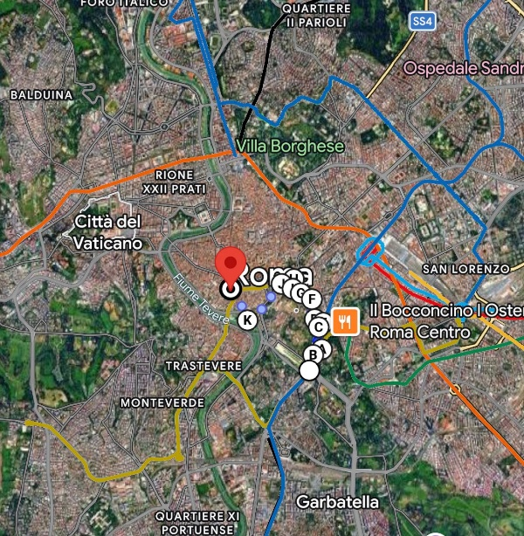
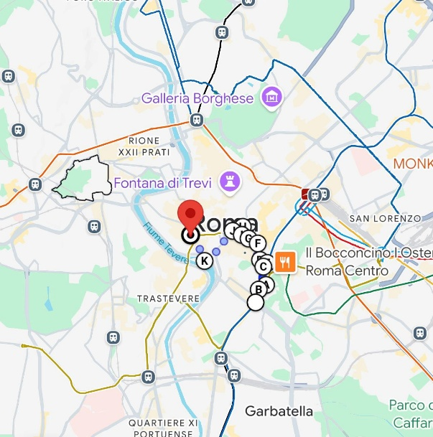

🎭 WELCOME TO THE CIRCO MASSIMO – WHERE ROMANS WENT WILD! 🏇💨
Ladies and gentlemen, history buffs and thrill-seekers, welcome to the Circo Massimo – the biggest, baddest, and most action-packed entertainment complex of the ancient world! Think of it as the Colosseum’s cooler, louder, and rowdier cousin, where Romans came not to politely admire statues, but to scream their lungs out, bet on reckless chariot drivers, and throw shade at rival fans!
Welcome to the Circo Massimo, folks – fasten your seatbelts and enjoy the ride! 🏇🔥
📜 THE ORIGIN STORY – A KIDNAPPING, A CIRCUS, AND A WHOLE LOT OF TROUBLE
Legend has it that the Circo Massimo was born out of pure chaos and romance gone wrong. Ever heard of the Rape of the Sabine Women? Well, long story short, the Romans (who at the time were basically a bunch of guys with no wives) decided to invite their Sabine neighbors to a ‘friendly’ festival right here. Then, instead of offering them snacks and drinks, they kidnapped their women and started a war. Classic Rome. 🎭 Over time, the place evolved from a muddy valley into the Formula 1 of the ancient world. Under Julius Caesar (around 46 BC, because of course, he had to get involved), the Circo Massimo got its first serious upgrade with real stone stands and actual organization. But it was Trajan in the early 2nd century AD who turned it into the colossal monster of entertainment you see before you today.
🏟 STADIUM STATS – SIZE MATTERS
If you think your local stadium is big, think again. The Circo Massimo was 600 meters long and 140 meters wide – big enough to fit three football fields side by side! It could hold up to 250,000 screaming fans, which means it would’ve made the modern Olympics look like a school sports day.
🎪 WHAT WAS ON THE SHOW?
What did the Romans come here for? Non-stop, adrenaline-pumping, wheel-spinning, gladiator-level chariot races!
🚀 Chariot Racing – The OG NASCAR: Forget horses gently trotting in circles – here, chariots flew at breakneck speeds, often resulting in spectacular crashes, flaming wreckage, and dramatic deaths. The crowd LOVED it.
🎭 The Spectators – The First Hooligans: Romans were die-hard fans, literally. Teams were divided by colors (Red, White, Green, and Blue), and if your team lost, things could get...well, violent. Let’s just say, modern football ultras had nothing on these guys.
🔥 Public Executions & Gladiator Fights – Because why stop at chariot racing when you can also watch criminals get thrown to the lions during half-time?
🎉 Parades & Political Propaganda: Emperors loved a bit of self-promotion, so they used the Circo Massimo for grand processions, military parades, and the occasional over-the-top victory celebration.
⏳ THE END OF AN ERA – FROM GLORY TO GAS METERS
Like all great things, the Circo Massimo had its rise and fall. After Rome got invaded a few too many times, people lost interest in watching chariots flip over and started worrying about basic survival. By the 6th century AD, the stadium became a fancy vegetable garden. Fast forward a few centuries, and the place was covered in gas tanks, warehouses, and even factories! It wasn’t until the 20th century that someone finally thought, “Hey, maybe we should stop parking trucks here and actually, you know…excavate?” And so, the grand rebirth of the Circo Massimo began.
🎮 CIRCO MAXIMO EXPERIENCE – TIME TRAVEL, BUT MAKE IT COOL
But wait, there’s more! Thanks to cutting-edge technology, you don’t have to just imagine the Circo Massimo in its glory days – you can SEE it come to life! Using augmented reality (AR) and virtual reality (VR), you can literally stand where ancient Romans stood, hear the deafening roars of the crowd, see chariots race at insane speeds, and even experience a full day at the races.
⏳ THE EXPERIENCE INCLUDES:
🏛 A trip back to when the valley was just a swamp full of sheep.
🛠 The rise of Julius Caesar’s grand redesign in 46 BC.
🔥 The golden era of Trajan – think Las Vegas meets Fast & Furious.
🏰 A medieval rollercoaster of destruction, abandonment, and re-use (6th-19th century AD).
🎭 Final stop: Today’s Circo Massimo, where concerts and joggers reign supreme.
🚀 FINAL THOUGHTS – WHY VISIT THE CIRCO MASSIMO?
Because where else can you:
- Walk in the footsteps of chariot-racing legends?
- Pretend to be a gladiator in the middle of an epic crash?
- Stand in a spot that has been everything from a racecourse to a medieval fortress to an industrial dumping ground?
🗺️ WELCOME TO THE MUSEO DELLA FORMA URBIS – WHERE ROME'S BLUEPRINT GETS A PLOT TWIST! 🏛️💥
Step right up, ladies and gentlemen, because you are about to witness the world’s oldest, most broken jigsaw puzzle! Welcome to the Museo della Forma Urbis, home to ancient Rome’s Google Maps, a gigantic marble map carved between 203 and 211 AD that once displayed every nook and cranny of the Eternal City! That’s right – before GPS, before paper maps, before that annoying friend who insists they know the way, there was the Forma Urbis.
🏛 See it, walk on it, and marvel at it – Rome’s past is literally beneath your feet! 🏛
📜 A MAP SO BIG, IT NEEDED A TEMPLE
So how big are we talking? The original Forma Urbis measured 18 by 13 meters (that’s about the size of a two-bedroom apartment, but much heavier) and was etched onto 150 slabs of marble. This colossal creation was attached to a wall in the Temple of Peace, in what is now the Roman Forum. If that sounds excessive, remember, Romans never did anything small – if they could chisel it into marble, they would.
The purpose of this ancient urban masterpiece? Well, scholars still debate whether it was a tool for city planning, a reference for architects, or just a glorified piece of imperial propaganda to flex Rome’s grandeur. What we do know is that it had every street, every temple, every shop meticulously engraved at a scale of 1:240 (which means they needed really tiny chisels).
🧐 THE GREAT MAP MASSACRE – WHERE DID IT ALL GO?
If you’re wondering why you’ve never seen this legendary map in its entirety, here’s where things take a turn for the tragic (and slightly ridiculous). Over time, the map fell victim to the greatest enemy of archaeology: human stupidity.
🔹 In 1562, some fragments were discovered – but by then, most had been looted, repurposed, or used to prop up wobbly medieval tables. 🔹 Over the centuries, marble thieves and lazy builders casually hacked away at the slabs and used them as raw materials for new structures. 🔹 Today, we have only about 10% of the original map left, scattered across hundreds of tiny fragments. To put that in perspective, imagine trying to put together a 1000-piece puzzle with only 100 pieces left… and half of them are in someone else’s attic.
🏛 FROM LOST TREASURE TO TOURIST HOTSPOT
But fear not! Thanks to the genius of modern archaeology, about 200 fragments have been identified and are now displayed right here at the Museo della Forma Urbis, in what was once a Fascist-era gym (because Rome’s history is nothing if not layered with irony).

🔹 Walk on history! The museum cleverly places these marble puzzle pieces on top of an 18th-century map of Rome, created by Giovanni Battista Nolli in 1748. This means you can literally stroll across centuries, comparing ancient Rome with its (only slightly less chaotic) modern version.
🔹 See the remains up close! Unlike traditional museums that keep everything behind glass, here you can walk on a transparent floor, getting a bird’s-eye view of ancient Roman urban planning (without needing a time machine).
🔹 Interactive fun! The museum isn’t just about dusty stones and Latin inscriptions – it’s packed with reconstructions, interactive displays, and juicy tidbits on how the map was made, used, lost, and rediscovered.
🏗 FROM GLORY TO RUBBLE TO GLORY AGAIN
Like all great things in Rome, the Forma Urbis had its highs and lows:
🔸 203-211 AD: Commissioned under Septimius Severus (because he wanted people to literally bow before Rome’s greatness).
🔸 4th-6th Century AD: Rome starts crumbling, and the Forma Urbis becomes just another wall decoration.
🔸 Middle Ages: Marble becomes prime real estate for DIY projects, and pieces of the map are stolen, broken, or turned into kitchen countertops.
🔸 1562: Someone finally realizes, "Hey, this might be important!" and archaeologists start piecing it back together.
🔸 1903-1924: The first major display of fragments at the Capitoline Museums.
🔸 2023: The grand opening of the Museo della Forma Urbis, finally giving this incredible artifact the attention it deserves.
🚀 WHY YOU CAN’T MISS THIS PLACE
Think of this museum as the ultimate detective story – part history, part mystery, part ‘what were they thinking?!’
✔️ You get to walk over 1800 years of history. ✔️ You can see how Romans planned their city (and how much of it is still standing today!). ✔️ You’ll leave with enough fun facts to impress at dinner parties for years to come. ✔️ And let’s be honest – when else will you get to see an ancient map that was literally hacked to pieces and miraculously put back together?
So, whether you’re a history nerd, a map geek, or just someone who loves a good Roman scandal, the Museo della Forma Urbis is the place for you. Come for the marble, stay for the mystery, and leave with a newfound respect for ancient cartographers (seriously, how did they do this without Google Earth?).

🏛️ WELCOME TO THE COLOSSEUM ARCHAEOLOGICAL PARK – THE STAGE OF HISTORY! 🎭🔥
Ladies and gentlemen, grab your cameras and prepare for a time-travelling adventure, because we’re about to catapult straight into the epicentre of ancient Roman greatness! Welcome to the Colosseum Archaeological Park, a spectacular mix of history, glory, and—let’s be honest—some truly epic disasters. Here, among temples, imperial palaces, and triumphal arches, every stone has a story to tell. Spoiler alert: most of these stones have witnessed more drama than your favourite TV series.
🏛 We’re waiting for you at the Colosseum Archaeological Park—where history has never been so alive! 🏛
📜 THE ARCHAEOLOGICAL PARK: A MASSIVE DOSE OF HISTORY IN A SINGLE STROLL
Established in 2017, the Colosseum Archaeological Park is a dream come true for history lovers. It encompasses the legendary Colosseum, the awe-inspiring Roman Forum, the sacred Palatine Hill, the majestic Domus Aurea, the iconic Arch of Constantine, and even the enigmatic ruins of the Meta Sudans. In short, it’s a colossal mashup of blood, sweat, and imperial triumphs all in one grand park. Every year, millions of visitors wander through these ruins, mesmerised by the grandeur of Roman civilisation—and, let’s face it, by the Romans’ refusal to do anything on a small scale. Wanted an amphitheatre? They built the biggest one. Needed a residence? They created a palace bigger than an entire district.
🏟 THE COLOSSEUM: WHERE IT ALL BEGAN
Here it is—the giant of Rome. The Colosseum, also known as the Flavian Amphitheatre, is the undisputed king of Roman monuments. Built in the 1st century AD by the emperors Vespasian and Titus, this travertine titan (hence the name!) could hold over 50,000 spectators, all eager to watch gladiator fights, exotic animal hunts, and over-the-top spectacles.
🔹 80 AD: Emperor Titus inaugurates the Colosseum with 100 days of continuous games (yes, you read that right—100 DAYS OF CELEBRATION!).
🔹 438 AD: Emperor Valentinian III bans gladiator fights because 400 years of bloodshed was probably enough.
🔹 Middle Ages: The Colosseum is repurposed as a marble quarry and, at one point, even a residential complex. Yes, people actually lived inside it!
🔹 19th century: Romanticism transforms it into a symbol of Rome’s lost grandeur, attracting artists, poets, and dreamers from all over the world.
🔹 Today: The Colosseum still stands, more fascinating than ever, ready to amaze anyone who walks through its ancient arches.
🤺 SPECTACLES & GLADIATORS: THE ORIGINAL NETFLIX
If you think Romans were content with just a casual chariot race, think again. Here, they staged naval battles (with real water!), ferocious beast hunts, and epic duels between gladiators.
Gladiators were the rock stars of their time, boasting fan clubs and intense rivalries akin to modern-day football hooligans. Their fights were so popular that they spawned stadium betting wars. If people today argue over football teams, back then, they literally fought over their favourite gladiators.
🏛 THE ROMAN FORUM: THE POWER CENTRE OF THE EMPIRE
If the Colosseum was the entertainment hub, the Roman Forum was the political nerve centre. This was where laws were debated, treaties were signed, wars were declared (or desperately avoided). It was a place of speeches, triumphs, trials, and legendary scandals—because in Rome, politics was truly a grand spectacle.
🛕 THE PALATINE HILL: BEVERLY HILLS OF ANCIENT ROME
Want to be someone in Rome? You had to live on the Palatine Hill. It was the VIP neighbourhood, where emperors built palaces so vast that today it would take an entire city to rebuild them. Augustus, Tiberius, Domitian—all the big names wanted a breathtaking view of Rome, and the Palatine was the prime real estate.
🎭 PAST MEETS PRESENT: THE PARK TODAY
Today, the Colosseum Archaeological Park is an immersive journey through history. You can explore ancient cobblestone streets, walk among broken columns, and imagine the echo of footsteps from emperors and senators. The park is not just an open-air museum—it hosts exhibitions, cultural events, and multimedia installations, making history come alive in a whole new way.
🚀 WHY YOU CAN’T MISS THIS EXPERIENCE
✔️ Because you’ll walk in the same arena as the gladiators. ✔️ Because you’ll see where Julius Caesar and Augustus changed the world. ✔️ Because you’ll admire Rome from the heights of the Palatine like a true emperor. ✔️ Because it’s one of the most thrilling experiences you can have in the Eternal City!
💡 EXPERT TIPS:
📌 Wear comfortable shoes! The park is enormous, and you’ll be walking a lot—but every step is a step into history. 📌 Book in advance! Avoid the queues and make the most of your visit. 📌 Visit at sunset! The illuminated Colosseum is one of the most spectacular sights in Rome.

🏛 WELCOME TO THE COLOSSEUM MUSEUM – WHERE HISTORY MEETS GLADIATORS AND EMPERORS! 🏛
Ladies and gentlemen, thrill-seekers, history nerds, and lovers of all things dramatic—welcome to the Colosseum Museum, a place where marble meets blood, legends meet reality, and emperors meet their fates!
🏛 Ready to uncover the secrets of the Colosseum? Step inside, walk in the footsteps of warriors, and relive the greatest show on Earth! 🎭🔥

WHAT IS THE COLOSSEUM MUSEUM?
If the Colosseum itself is a blockbuster movie, then the Colosseum Museum is the behind-the-scenes documentary! Located on the second level of the amphitheater, this museum is your exclusive VIP access to the history, secrets, and artifacts of the greatest gladiatorial arena ever built.
Here, you'll find incredible relics, detailed reconstructions, and jaw-dropping facts that will make you rethink everything you thought you knew about the Roman Games, ancient engineering, and the brutal reality of entertainment in ancient Rome.

THE MAKING OF A LEGEND: A COLOSSEUM TIMELINE
🏗 70-80 AD – Construction begins! Emperor Vespasian says, “You know what Rome needs? The ultimate sports stadium.” His son, Titus, completes the Colosseum in 80 AD, celebrating with 100 days of games (translation: a whole season of fights, beast hunts, and epic bloodbaths).
⚔ 1st-3rd century AD – Gladiator Glory Days – The Colosseum becomes the prime-time TV of Ancient Rome, hosting battles between gladiators, exotic animal hunts, and even full-on naval battles (yes, they flooded the arena!).
🔥 217 AD – Fire strikes! A massive fire damages the Colosseum, proving that even Romans needed a good fire safety plan. Restoration takes decades, but the games continue.
⛪ 5th century AD – The End of an Era – Gladiatorial games are officially banned in 438 AD by Emperor Valentinian III. The Colosseum’s fighting days are over, but the drama is far from finished.
🏚 Medieval Period – The Colosseum’s Side Hustles – The arena turns into a castle, a market, a slum, a church, and even a quarry for building materials (some of its stones ended up in St. Peter’s Basilica!).
🎭 18th-19th century – The Romantic Ruin – The Colosseum becomes a symbol of lost grandeur, attracting artists, poets, and travelers on the Grand Tour. Lord Byron himself was obsessed with its eerie beauty!
🏛 20th-21st century – Restoration and Revival – The Colosseum undergoes extensive conservation work, and in 2007, it is officially named one of the New Seven Wonders of the World. Today, it’s the most visited monument in Italy.

WHAT YOU'LL SEE IN THE COLOSSEUM MUSEUM
🎭 The Architecture – Marvel at original pieces of the Colosseum, including carved capitals, decorative panels, and reconstructed vomitoria (the exits, not what you think!).
⚔ The Gladiator Section – Witness ancient graffiti, mosaics, and weapons that bring the gladiator lifestyle to life. Some of these warriors were the rock stars of their time!
🏛 The Spectators’ World – Discover how seating worked in the Colosseum: rich senators in the front, rowdy fans in the back, and women way up in the nosebleeds. Roman ticketing was strict!
🌙 The Medieval and Christian Colosseum – The Colosseum was not just about blood and battles. Over time, it became a place of worship, a fortress, and even a sacred site.
👑 The Colosseum as Propaganda – Learn how different emperors, popes, and even dictators have used and rebranded the Colosseum for their own messages.

WHY VISIT THE COLOSSEUM MUSEUM?
✔️ Get up close with ancient artifacts – See original statues, columns, and relics from one of the most iconic structures in the world.
✔️ Understand how the Colosseum worked – Explore the engineering genius that made trap doors, elevators, and stage effects possible.
✔️ Feel the gladiator experience – Learn what it really took to survive the games (spoiler: not much luck involved!).
✔️ See how history shaped the Colosseum – From glory to ruins, medieval takeovers, and Hollywood fame, this place has seen it all!
✔️ Enjoy breathtaking views – The museum is located on the second level, offering stunning views of the Colosseum, Roman Forum, and beyond!

TIPS FOR YOUR VISIT
✅ Wear comfortable shoes! Gladiators fought in sandals, but you should opt for sneakers.
✅ Arrive early – The museum is a must-see, and crowds can get gladiator-level intense.
✅ Bring water – The Roman sun can be as fierce as a lion in the arena.
✅ Use your imagination! These ruins once echoed with cheers, roars, and epic battles.

🏛 WELCOME TO THE ROMAN FORUM – THE ORIGINAL DOWNTOWN OF ANCIENT ROME! 🏛
Ladies and gentlemen, history lovers, and selfie enthusiasts, get ready to step into the heart of the most dramatic, chaotic, and fascinating place in ancient Rome, the legendary Roman Forum! If these ruins could talk, they’d probably roll their eyes and say, "You think modern politics is messy? Try surviving Roman Senate meetings!"
🏛 Ready to experience the Forum in all its chaotic, majestic, and jaw-dropping glory? Step into history and let the ruins speak! 🎭🔥

WHAT EXACTLY IS THE ROMAN FORUM?
Think of the Roman Forum as the ultimate mash-up of a city hall, a courtroom, a bank, a shopping mall, a social media hotspot, and a gladiator fan zone—all rolled into one chaotic, noisy, and absolutely thrilling place. This was where history was made for over a thousand years. Emperors were celebrated, traitors were humiliated, and deals were struck faster than a gladiator could dodge a spear. If ancient Rome had a reality show, this would have been its main set.

THE STORY BEHIND THE RUINS: FROM SWAMP TO SUPERPOWER
🌿 Before 700 BC – The area was nothing more than a disgusting, swampy valley where mosquitoes ruled like emperors.
🏗 Late 7th Century BC – Romans, tired of the swamp vibe, drained the area and paved the ground. The Forum was born! It quickly became the nerve center of Roman life, full of gossip, power struggles, and questionable deals.
⚔ 3rd – 2nd Century BC – Thanks to Rome’s war victories (including taking down Carthage), the Forum went full Hollywood mode with fancy basilicas, colossal temples, and shiny new buildings. Rome had money, and boy, did they love spending it!
👑 1st Century BC – Rise of the Caesars – Enter Julius Caesar, who decided the Forum needed some serious upgrades. He built the Basilica Julia, where Romans settled lawsuits (because, let’s be honest, even back then, people loved to argue). After his assassination in 44 BC (et tu, Brute?), they built the Temple of the Divine Julius Caesar—because nothing says "sorry for stabbing you" like a temple.
🏛 1st – 2nd Century AD – Imperial Glory Days – Augustus added the Temple of the Divine Julius, and later emperors, like Vespasian and Titus, built more grandiose structures. The Temple of Antoninus and Faustina, originally for an emperor and his wife, was later transformed into a church (because recycling was a thing, even back then).
🏆 203 AD – The Arco di Settimio Severo – This massive triumphal arch was built to celebrate Emperor Septimius Severus' victories against the Parthians. Fun fact: The arch still has an inscription, but the names of his sons were erased later (family drama, Roman edition).
🎭 4th Century AD – The Final Touches – Emperor Maxentius went all out, constructing an enormous basilica and a temple for his son Romulus. Rome was still thriving, but the Forum had seen better days.
📉 608 AD – The Last Monument – The Column of Phocas, a last-minute tribute to a Byzantine emperor, was erected. After this, the Forum slowly became a ghost town, buried for time.

FROM ROME’S HEART TO A MEDIEVAL COW FIELD
Once the center of civilization, the Forum eventually fell into ruin. By the Middle Ages, it was a pasture for cows (hence the nickname "Campo Vaccino"—literally "Cow Field"). The grand temples and majestic basilicas? Reduced to rubble, pilfered for materials, or transformed into churches. A few highlights from the Medieval makeover:
- The Curia Julia (where the Senate held its debates) was turned into a church.
- The Temple of Antoninus and Faustina was converted into the Church of San Lorenzo in Miranda.
- The Temple of Romulus? Became the Church of Saints Cosma and Damiano.
- Even the Mamertine Prison, where legendary figures like Vercingetorix and (allegedly) Saint Peter were held, got a church on top of it.

MODERN DISCOVERY: DIGGING UP THE PAST
Fast forward to the 19th century, and archaeologists finally decided to stop ignoring the buried ruins and start digging. Thanks to Italy’s unification in 1861, the first systematic excavations began, revealing the incredible remains of the world’s most famous political, social, and religious hub. Today, the Roman Forum is one of the most visited sites in the world, and for good reason. Every step you take here is a step through history—from the legends of Rome’s foundation to the emperors who ruled the known world.

WHY YOU CAN’T MISS THE ROMAN FORUM
✔️Walk in the footsteps of Julius Caesar, Augustus, and Marcus Aurelius.
✔️ See the ruins of temples, arches, and political buildings that once dictated the fate of Rome. ✔️ Imagine senators arguing, merchants selling, and priests performing sacred rituals.

PRO TIPS FOR VISITORS
✅ Wear comfortable shoes! The cobblestones are ancient, uneven, and out to get you.
✅ Visit early or late in the day to avoid the heat and crowds.
✅ Bring water! Rome’s sun is beautiful but brutal. ✅ Don’t rush! Take your time to soak in the atmosphere. This place wasn’t built in a day—don’t try to see it in five minutes.
🏛 WELCOME TO THE FORUM MUSEUM – WHERE HISTORY COMES TO LIFE! 🏛
Ladies and gentlemen, history buffs, archaeology lovers, and those who just love a good ancient mystery—welcome to the Forum Museum, the place where centuries-old ruins tell stories, emperors whisper secrets, and archaeologists celebrate their greatest finds!
🏛 Step inside the Forum Museum and walk in the footsteps of Rome’s legends! The past is waiting for you… 🎭🔥

WHAT IS THE FORUM MUSEUM?
If the Roman Forum is the ultimate Hollywood set of ancient politics, then the Forum Museum is your VIP backstage pass! Located inside the Chiostro di Santa Maria Nova, this museum is where the treasures of the Forum are finally displayed with the drama they deserve.
Discover ancient artefacts, mind-blowing reconstructions, and relics that will transport you back in time to the glory days of Rome—when senators debated, Vestal Virgins tended sacred fires, and emperors strolled like they owned the place (which, to be fair, they did).

A BRIEF HISTORY OF THE FORUM MUSEUM
🏛 1908 – The First Forum Museum – Archaeologist Giacomo Boni establishes the first Antiquarium to house his discoveries from the Forum. His idea? A research centre where artefacts remain in their original context. (Spoiler: not all museums think like this!)
⚒ 20th Century – Archaeology Never Sleeps – Excavations continue under experts like Dante Vaglieri, Alfonso Bartoli, and Pietro Romanelli, bringing new life (and new relics) to the Forum’s collection.
🎭 2020s – The New and Improved Forum Museum – The museum reopens with a dazzling new layout, showcasing legendary finds from the ancient burial grounds to the great basilicas and temples.

WHAT YOU’LL SEE AT THE FORUM MUSEUM
🛖 Ancient Burials & Mysteries of Rome’s Origins – Discover tombs dating back to the 10th century BC (that’s older than Rome itself!). Gaze upon beautifully restored burial urns, delicate grave goods, and the eerie reconstructions of ancient funerary sites.
🎭 Monuments of Power – Explore the fragments of the Basilica Emilia, including carvings that depict the founding of Rome, battles, and the infamous Rape of the Sabines (ah, those wild Romans).
🏛 The Fountain of the Gods – Marvel at statues of Apollo, Castor, Pollux, and Aesculapius—divine figures who once watched over the Forum’s most sacred waters.
🛡 The Secrets of the Sacred Forum – Step into the section dedicated to the most mystical sites: the Lapis Niger, the Regia, and the legendary Doliola—a place so ancient, even the Romans weren’t entirely sure what it was for!
🔥 The Home of the Vestal Virgins – Peek into the life of Rome’s most powerful priestesses, with relics from the Temple of Vesta and the House of the Vestals, including artefacts found in their sacred wells.
🎭 A Show of Politics and Power – Stand before the relics of the Temple of Venus and Rome and gaze at sculptures and friezes that tell of emperors, victories, and ancient propaganda at its finest.

WHY VISIT THE FORUM MUSEUM?
✔️ Discover the heart of ancient Rome – The Forum was THE place for politics, religion, and scandalous gossip!
✔️ Step inside history – See where Rome’s greatest minds and fiercest rulers once stood.
✔️ Admire rare artefacts – These treasures survived wars, fires, and looters—now, they’re finally on display for you.
✔️ Get the full picture – Ruins are great, but seeing the original statues, frescoes, and carvings makes the experience even richer!
✔️ Enjoy the views – The museum sits at the perfect spot for stunning panoramas over the Forum and Palatine Hill.

TIPS FOR YOUR VISIT
✅ Wear comfy shoes! Rome wasn’t built in a day, and it’s going to take you more than a few hours to explore it all.
✅ Bring water – The Roman sun is no joke, and the ancient gods won’t provide air conditioning.
✅ Come with curiosity – Every stone, every carving, every artefact has a story to tell—are you ready to listen?
✅ Take your time – The Forum Museum is a treasure chest of history, so don’t rush it!

🏛 WELCOME TO THE PALATINE HILL – WHERE LEGENDS, EMPERORS, AND REAL ESTATE DREAMS COLLIDED! 🏛
Ladies and gentlemen, history lovers, selfie enthusiasts, and gladiator wannabes, welcome to the Palatine Hill—the Beverly Hills of Ancient Rome! Forget about Hollywood mansions, this was the original VIP neighborhood where emperors, senators, and high-ranking Romans built their extravagant palaces, complete with marble floors, frescoed walls, and views to die for (literally, if you upset the emperor).
🏛 Ready to experience the Palatine? Step into history, breathe in the past, and enjoy the ruins that once housed Rome’s most powerful figures! 🎭🔥

WHAT IS THE PALATINE HILL?
Think of the Palatine Hill as the first-ever luxury residential district. If you were rich, famous, or just really good at stabbing political rivals in the back, this was the place to be. Overlooking the Roman Forum on one side and the Circus Maximus on the other, it was the ideal spot for spying on chariot races and Senate scandals—all from the comfort of your private villa.
But the Palatine is more than just fancy houses. According to legend, this is where Rome was born! Yep, this very hill was where the she-wolf (Lupa) allegedly nursed Romulus and Remus before Romulus (classic big brother move) decided to found the city and, for good measure, kill Remus. Ah, family drama—nothing’s changed in 2,700 years!

FROM BRONZE AGE HUTS TO IMPERIAL PALACES
🏕 Before 750 BC – The Palatine was home to early settlers, living in little huts. Not exactly five-star accommodation, but hey, it was home.
🏗 7th Century BC – Romans start upgrading. The swampy Forum below is drained, and the Palatine becomes prime real estate. Think of it as an early property boom!
🏛 2nd–1st Century BC – The Aristocrats Move In – Wealthy Roman families build lavish mansions with intricate mosaics, elegant columns, and private gardens. If you weren’t rich, you weren’t living here—simple as that.
👑 27 BC – Here Comes Augustus! – The first emperor of Rome, Augustus, moves in and transforms the Palatine into a symbol of power. He builds his own palace, the Domus Augustana, making sure everyone knows who’s boss. Fun fact: “Palatium” (Palatine) is where the word “palace” comes from!

🛕 1st Century AD – The Imperial Era – Emperors go all out. Tiberius builds Domus Tiberiana, Nero constructs the Domus Transitoria, and later the Domus Aurea (the infamous Golden House). By the time of Domitian, the Palatine is packed with marble halls, underground corridors, and grand reception rooms fit for a god (which emperors thought they were).
🎭 Nero’s Hidden Tunnels – Because normal hallways weren’t dramatic enough, Nero built a secret underground passageway (Criptoportico Neroniano) to connect his many, many palaces. Perfect for sneaking out of awkward Senate meetings or dodging assassination attempts.

THE RENAISSANCE TAKEOVER
Fast forward to the 16th century—long after Rome’s emperors were gone, the rich noble families of the Renaissance turned the Palatine into a private paradise of gardens, fountains, and villas. The Horti Farnesiani still stand today, proof that people always find ways to turn ruins into real estate investments!

WHY VISIT THE PALATINE HILL?
✔️ Walk where Rome began—literally, the birthplace of Rome is right here!
✔️ Feel like an emperor—stand inside the ruins of Domitian’s Palace and imagine ruling an empire.
✔️ Enjoy breathtaking views—the Palatine offers stunning panoramas of the Forum and Circus Maximus (ideal for dramatic Instagram shots).
✔️ See ancient luxury—admire the remains of extravagant Roman villas, frescoes, and secret passageways.
✔️ Escape the crowds—unlike the Forum or Colosseum, the Palatine is quieter and more scenic—a perfect place to soak in history at your own pace.

TIPS FOR VISITING
✅ Wear comfortable shoes! Ancient emperors loved stairs, and so will you.
✅ Bring water! Rome gets hot, and Nero’s not here to provide refreshments.
✅ Visit in the morning—less heat, fewer tourists, and better lighting for photos.
✅ Use your imagination! What looks like a pile of bricks was once a lavish imperial palace.

🏍️ WELCOME TO THE VESPA MUSEUM – WHERE ICONS RIDE THROUGH HISTORY! 🏍️
Ladies and gentlemen, two-wheel enthusiasts, lovers of vintage charm, and travelers in search of the true Roman experience—welcome to the Spazio Museo Vespa, where scooters aren’t just vehicles; they’re legends!
🏍 Step into the Vespa Museum and ride through the history of a true Italian icon! ✨

WHAT IS THE VESPA MUSEUM?
Imagine stepping into a time machine, but instead of gears and wires, it’s got a kickstand and a Vespa logo! Tucked away inside the Bici & Baci store on Via Cavour 302, this museum is a love letter to Italy’s most famous two-wheeled creation. From 1946 to today, every curve of a Vespa tells a story of freedom, innovation, and cinematic fame!
Here, you’ll find legendary models, memorabilia from iconic films, and stories of riders who took their Vespas to places no one ever thought possible!

A BRIEF HISTORY OF THE VESPA MUSEUM
🏍 July 12, 2013 – Grand Opening – Inaugurated in honor of the 60th anniversary of "Roman Holiday", the museum opened with a bang, welcoming ambassadors, celebrities, and Vespa fanatics.
🎥 1953 – The Vespa Becomes a Hollywood Star – "Roman Holiday" premieres, featuring Audrey Hepburn and Gregory Peck riding through Rome, instantly turning the Vespa into an international icon.
🌍 2000s – The Global Journey Begins – Adventurers from all over the world, from Indonesia to Argentina, embark on epic cross-continental journeys aboard their beloved Vespas.
🚀 Today – The Vespa Revolution Continues – From collectors to city commuters, the Vespa remains a timeless piece of Italian culture.

WHAT YOU’LL SEE IN THE VESPA MUSEUM
🏆 The First Vespa Ever Made! – Marvel at the first-ever Vespa frame, a sleek metal masterpiece that started it all in 1946.
🎬 Movie Star Vespas – Stand inches away from the Vespa Faro Basso used in "Roman Holiday"—arguably the most famous scooter in cinema history!
🏁 Racing Legends – Discover the Vespa of champion rider Roberto Leardi, displayed with his original racing suit.
🌍 The Ultimate Road Trip Scooter – Be amazed by the Vespa that crossed two continents from Indonesia to Rome, proving that with a Vespa, the world is your road!
📜 Decades of Italian Style – Explore how Vespa’s design evolved, from the sleek 1950s classics to the modern electric models.

WHY VISIT THE VESPA MUSEUM?
✔️ It’s a free ride through history! – No ticket required, just pure Vespa love!
✔️ Step into a Roman Holiday – Feel like Audrey Hepburn (or Gregory Peck) and relive the most famous Vespa scene in history.
✔️ See rare, original Vespas – From racing to cinema, these scooters have seen it all!
✔️ Learn the real Italian way to travel – Because let’s be honest, you haven’t truly lived Rome until you’ve been on a Vespa!
✔️ Perfect photo ops – Pose with a classic Vespa against the backdrop of history—Instagram will thank you.

TIPS FOR YOUR VISIT
✅ Don’t rush! – Every Vespa has a story—take your time to soak it all in.
✅ Ask questions – The staff knows everything there is to know about Vespas, Rome, and wild two-wheeled adventures!
✅ Rent a Vespa after your visit! – Want to experience Rome like a local? The museum is inside Bici & Baci, so you can ride away on your own Vespa right after your visit!
✅ Take the perfect "Roman Holiday" shot! – Straddle a Vespa, channel your inner Hepburn, and capture the moment!

🏛️ WELCOME TO THE MUSEUM OF THE IMPERIAL FORA AT TRAJAN'S MARKETS! 🏛️
Ladies and gentlemen, time travelers and history lovers, get ready for an unparalleled journey into the past! Here, among the ancient walls of Trajan's Markets, awaits a museum that is not just a collection of artefacts, but a true time machine to relive the grandeur of Imperial Rome!
🏛 Come to the Museum of the Imperial Fora and prepare for an epic journey into Ancient Rome! 🏛✨

WHAT ARE TRAJAN'S MARKETS?
Imagine walking through the remains of a district that has lived more lives than a Roman cat! 🎭 From the Imperial Age to today, this place has been an administrative centre, a fortress, a convent, a military barracks, and even a noble residence! Every stone tells a story, and we’re here to share it with a pinch of irony and a lot of passion!

A BIT OF HISTORY (BUT NOT TOO BORING!)
⚒ 112-113 AD – Emperor Trajan inaugurates his Forum, the largest and most spectacular ever built. And where to manage administration and commerce? In Trajan’s Markets, of course!
🏰 Middle Ages – The complex is repurposed as a military fortress. Why? Because Rome was a bit like the Wild West, and protecting oneself was always a good idea!
🕍 Renaissance – The nobility transform the site into convents and luxurious residences. The history keeps layering… literally!
🔎 1926-1934 – Excavations reveal the true face of Trajan’s Markets, but only in 2007 is the museum officially inaugurated to tell this incredible story.

WHAT WILL YOU FIND IN THE MUSEUM?
🏛️ A unique collection of artefacts – From original fragments to breathtaking reconstructions of the architectural decorations of the Imperial Fora. A true feast for the eyes!
📜 Everyday life in the Empire – Who visited the Fora? What was sold? Who ruled? Discover it all through artefacts, interactive panels, and multimedia installations.
🛠 Ancient technology – Ever wondered how they built these monumental structures without modern cranes? Well, here you’ll find out!
🎥 Multimedia and interactivity – With videos, projections, and digital reconstructions, you can see Trajan’s Forum in all its original splendour.

WHY SHOULD YOU VISIT THIS MUSEUM?
✔️ It’s a journey back in time – No time machines needed, just the magic of history!
✔️ It’s perfect for the curious – From history nerds to architecture lovers, there’s something for everyone.
✔️ You’ll see a piece of Imperial Rome… as if you were there!
✔️ Epic photo opportunities guaranteed – Selfies with ruins? Of course, it’s Rome after all!

TIPS FOR YOUR VISIT
✅ Don’t rush – Every corner tells a story. Take your time, observe, and be amazed.
✅ Make the most of technology – Tablets, videos, and projections make the visit even more immersive.
✅ Enjoy the view – The museum is nestled within Trajan’s Markets, and the walk among the ruins is simply spectacular!

